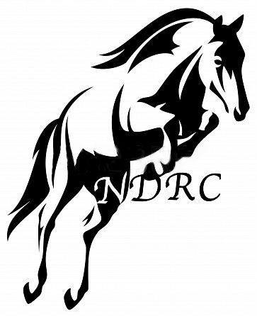
DRESS CODE

Please take a moment to read our ‘Dress Code’ for the shows held at Swinderby. Please keep in mind that you may be marked down for incorrect dress should the judge deem your attire inappropriate.
Meanwhile showing is a great way to have fun with your horse and to let your competitive side come out! Show off skills that you have acquired through riding and stretch your talent outside the stables!
Showing takes confidence, determination as well as the proper attire. You want to make sure you are properly dressed for the type of show you are entering and that you meet the dress code regulations.

Tack & Turnout / Ridden showing
Horse / Pony wear
- Lead rein to be attached to the noseband and only snaffle bits allowed
- Leaders to be smartly dressed, shirt, trousers, skirt, jacket or waistcoat & hat (optional) with hair neatly tied.
- Snaffle, Pelham or double bridle allowed.
- No saddle cloths, martingales, boots or schooling aids permitted on the pony / horse.
- A dark shaped numnah
- Horse / pony to be plaited unless a native breed shown in natural state
Rider wear
- Cream/beige jodhpurs, jacket, shirt, tie, gloves, showing cane and hair neatly tied.
- Junior riders: Jodhpur boots
- Senior riders: Long boots

In hand
Horse / Pony wear
- Bridle or In hand bridle
- Plaited or non-plaited depending on breed
- Smart dress, appropriate footwear NO trainers. NO jeans or shorts
- Hard hats to be worn by juniors.

Working Hunter
Horse / Pony wear
- There is no requirement for a change of tack during the Working Hunter.
- Bridles should be plain with no colour NO BLING
- No bandages or schooling aids
- Boots may be worn for the jumping phase at the judge’s discretion
- NO saddle cloth / pad
- Dark shaped numnah
Rider wear
- Cream/beige jodhpurs, tweed jacket, shirt, tie, hat, gloves & hair neatly tied.
- Junior riders: Jodhpur boots
- Senior riders: Long boots
- A body protector (optional, highly recommended)

Show Jumping (Main ring)
Horse / Pony wear
- BLING PERMITTED
- Boots permitted
Rider wear
- Cream/beige or white jodhpurs
- Tweed / Show jacket (may be taken off at club’s discretion
- Tie or stock)
- Shirt (upper arm to be covered)
- Junior riders: Jodhpur boots
- Senior riders: Long boots
- Dark chaps or gaiters allowed
- A body protector (optional / recommended)
- Spurs can be worn 10 years & over

Games, Roll out the Barrel & Horse / Pony judge would like to take home
Horse / pony wear
- Appropriate tack
- Lead rein to be attached to the noseband
Rider wear
- Light coloured jodhpurs
- Smart T-shirt / Sweatshirt may be worn
- Body protector (optional)

